Why I finally bought HYPE: Hyperliquid bull case
I must be honest - at first, I completely faded Hyperliquid. I didn't participate in the airdrop because I dislike farming perps, so I missed out there. I didn’t buy in close to TGE either, still fading Hyperliquid, so missed the entire move up. I generally only buy on deep retraces, so now at $13, I finally bought HYPE. In this article, I'll analyze why Hyperliquid might have a great future ahead.
This is not financial advice. This is just what I do with my money. I might lose on this trade and prices might very well go lower. This article is intended to give you insights about what is happening on Hyperliquid so you can research and come to your own conclusions.

Reason 1: Great product with product market fit
The platform is exceptionally well built: super responsive, lightning fast, and with intuitive UX. The team has created a truly frictionless trading experience. This frictionless experience is possible because of their high-throughput infrastructure, which delivers 100K transactions-per-second with sub-second finality. The technical foundation creates an experience that feels like a centralized exchange while maintaining the benefits of decentralization.
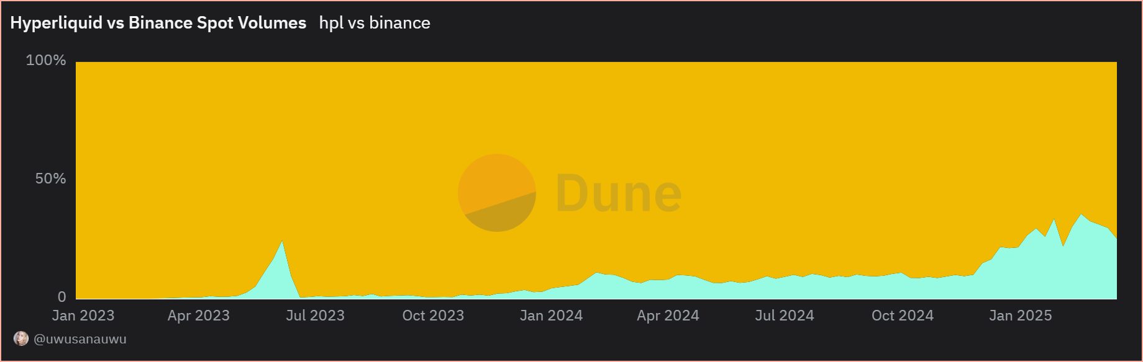
This amazing user experience has allowed Hyperliquid to grow rapidly. At this point, it is already doing 30% of the spot volume that Binance handles - a remarkable achievement for such a young protocol. The platform is literally eating into Binance's market share, which speaks volumes.
The revenue numbers further validate this product-market fit. Hyperliquid is generating annualized revenues of S771M from just its perp exchange and nascent spot markets, putting it ahead of renowned DeFi applications like Maker and Aave. This revenue generation capacity is especially impressive when you consider that Hyperliquid ranks among the top fee-generating protocols in all of crypto, despite being relatively new to the scene. To dive deeper into Hyperliquids Revenue analysis, read my previously published episodes on the DeFi protocols generating the most revenues.
https://lukasinho.substack.com/p/the-best-opportunities-in-defi

Reason 2: Powerful Value Accrual Mechanisms
Unlike many other utility coins, HYPE has strong value accrual mechanisms. The primary one being the Assistance Fund, which receives almost all trading fees from Hyperliquid (the remainder goes to HLP, their market making vault). This fund then uses these fees to buy HYPE on the open market.
The Assistance Fund has already purchased over $324 million worth of HYPE from the open market in just the past three months, accumulating approximately 5.2% of the circulating supply. This creates consistent buying pressure that directly benefits token holders, regardless of market conditions. Since these tokens aren't burned, they form a strategic warchest that can be used for future growth, held to reduce circulating supply, or redeployed as needed. This flexibility gives the protocol more options, though it's worth noting that any future redeployment could create temporary sell pressure.
Additionally, the platform's ticker auction system creates another value capture mechanism. Projects pay to secure their ticker symbols on Hyperliquid through auctions happening every 31 hours. Given the limited availability (only ~282 auctions possible per year), prime "tickerspace" is becoming increasingly valuable as more projects seek to establish presence on the platform.
Beyond the exchange functionalities, HYPE's value accrual extends to the recently launched HyperEVM ecosystem. This expansion transforms Hyperliquid from a perps DEX into a complete blockchain platform with its own DeFi ecosystem. The HyperEVM runs alongside the order book exchange, creating a unified state where both interact seamlessly without bridges or external oracles.
Within this ecosystem HYPE serves as the central store of value. Both users and protocols building on HyperEVM can use HYPE for various purposes - from providing liquidity and earning yield to using it as collateral. Some projects are already committing to allocate portions of their treasury to HYPE, further driving demand, as Ryan Watkins points out in his Hyperliquid thesis.
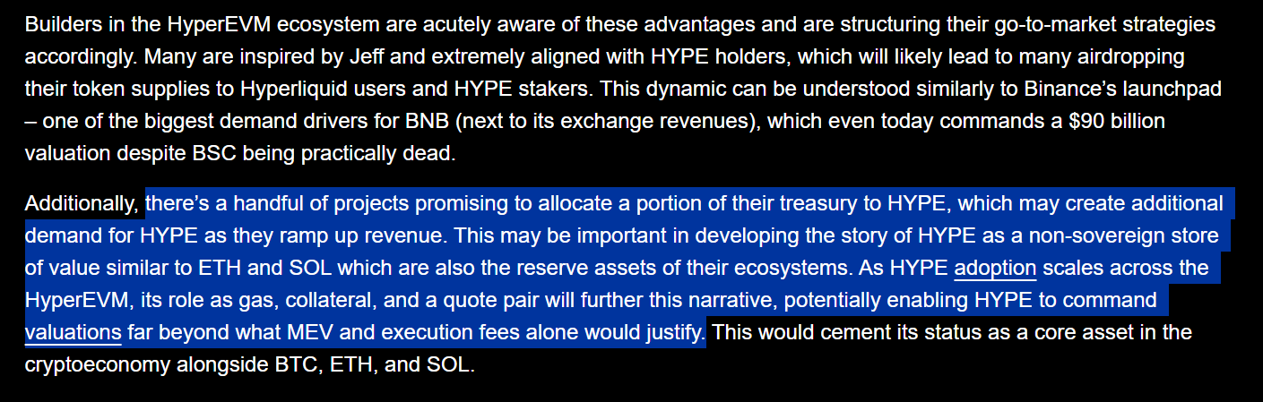

Reason 3: The "Financial Aggregator" Model
What makes Hyperliquid truly special is its unique position as what Ryan Watkins calls a "Financial Aggregator." Unlike other projects that focus on being either an exchange or a smart contract platform, Hyperliquid combines both into a vertically integrated system.
This integration happens through HyperCore and HyperEVM working together as one unified system. HyperCore contains specialized native components: perp and spot orderbooks, staking, oracles, and multi-sig functionality. HyperEVM is a general-purpose blockchain that lets developers deploy code interacting with both systems. Together they form ONE composable state secured by the same consensus mechanism.
The key advantage here is that there's no need for bridging, proofs, or trusted signers between the exchange and smart contracts - a problem that plagues the Ethereum ecosystem. This creates powerful synergies that no other project can match.
For example, a token deployed on HyperEVM can be seamlessly linked to a corresponding spot asset on HyperCore, allowing users to transfer their balance between systems for orderbook trading without any bridging risk. Similarly, lending protocols on HyperEVM can read price data directly from HyperCore orderbooks and execute liquidations directly on those same orderbooks - far more efficient than AMM-based liquidations on other chains.
This vertical integration also creates a powerful user aggregation effect. By combining the exchange interface, orderbook, and smart contract platform into one cohesive experience, Hyperliquid can aggregate users at scale. This gives it unmatched leverage over developers and asset issuers compared to more fragmented ecosystems.
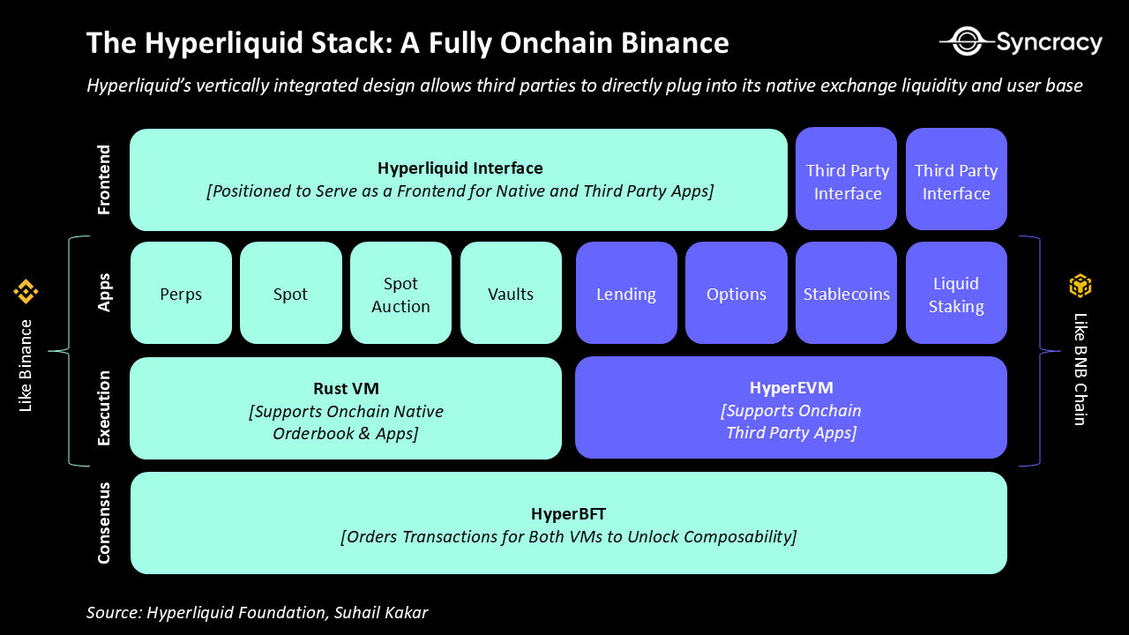
The design contrasts sharply with how most crypto infrastructure has developed. Base is Ethereum's most successful rollup but remains mostly separate from Coinbase's product suite. Uniswap verticalized many components but inherited Ethereum's technical limitations. Solana outsources much of its user experience to external builders. Hyperliquid instead integrates the entire stack, creating a powerful feedback loop where the exchange drives users to applications, which in turn enhance the exchange's value.

Reason 4: Aligned Incentives & Founder Integrity
Unlike most crypto projects which take substantial funding from VCs and private investors, Hyperliquid is entirely self-funded.
The HYPE token has zero allocations to market makers, private investors, or exchanges. This means there's no massive overhang of early investors waiting to dump their tokens once they unlock. Core contributor tokens are locked until late November, with most vesting completing between 2027 and 2028.
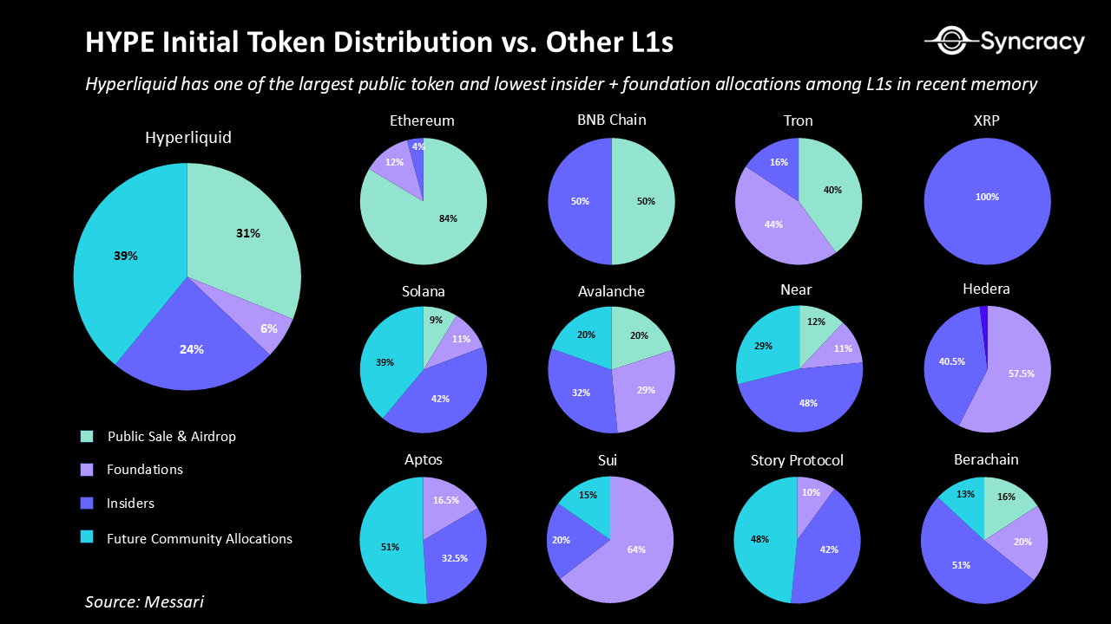
This funding approach created a refreshingly aligned incentive structure. Without external funding, the team was able to focus purely on building a product they believed in, rather than rushing to satisfy investor demands for quick returns.
The founders' product-first philosophy is evident in Hyperliquid's development history. Rather than optimizing for ideological purity, like maximizing decentralization from day one, the team prioritized delivering the best possible on-chain trading experience. This progressive decentralization approach allowed them to first find product-market fit, then gradually relinquish control.
This strategy proved invaluable as the team maintained direct engagement with traders, implementing feature requests and bug fixes sometimes within hours. This feedback loop built deep trust within the community and led to critical product features that competitors lacked.
The team has also demonstrated exceptional community-building capabilities. Their generous airdrop rewarded early users and contributors, helping create a tight-knit community of supporters. This approach has given the protocol remarkable stickiness, similar to how Solana's dedicated community helped it survive the FTX crash and last bear market.
By combining self-funding, extended vesting, community focus, and product-first development, Hyperliquid's founders have created an environment where their incentives align perfectly with long-term token holders. This alignment stands in stark contrast to many projects where early investors and teams extract value at retail's expense.

Risk Factors & Challenges
While the bull case for Hyperliquid is compelling, there are several challenges that could impact its growth trajectory. Being clear-eyed about these risks is essential for any investment decision.
The most immediate concern is the current state of the HyperEVM. Unlike the highly performant HyperCore exchange, the HyperEVM's alpha release has faced performance issues. Users have experienced problems with gas fees spiking during NFT mints, network congestion, confusion over enabling big block/small blocks, and nonce issues. These technical hurdles have resulted in a somewhat subpar user experience that falls short of expectations.
This performance gap has likely contributed to the slow development of the HyperEVM ecosystem. Despite being live for nearly a month, the total value locked (TVL) sits at just $11.3M - a modest figure considering HYPE's market capitalization. The early DeFi primitives are live (HypurrFi, KittenswapHype, KeikoFinance, etc.), but money isn't flowing to the HyperEVM at the pace some expected.
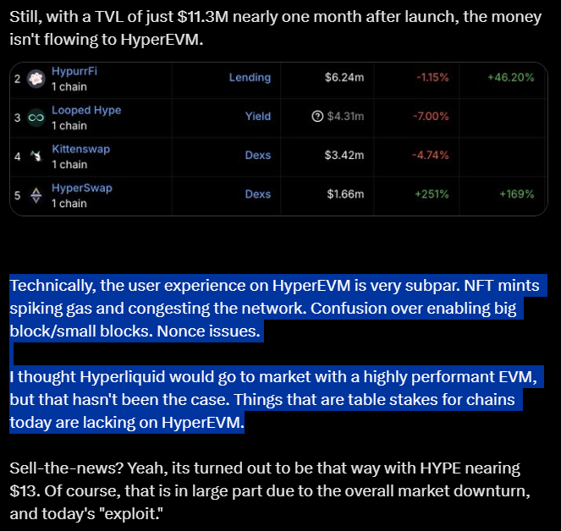
https://x.com/Solofunk30/status/1899877956148969569
Addressing these ecosystem growth challenges might require investments in initiatives like incentives, grants programs, and marketing. While the project has a massive chest of HYPE tokens (38.88% allocated for "future emissions and community rewards"), any deployment of these tokens would introduce sell pressure in the short term.
The validator network structure also raises some decentralization concerns. While Hyperliquid is moving toward a permissionless validator system, the exact details of validator operations remain somewhat opaque. For true decentralization and security, Hyperliquid will need to become more transparent about how validators function.
Despite these challenges, the Hyperliquid team has demonstrated the ability to iterate quickly and solve complex problems. If they can improve HyperEVM performance, bootstrap ecosystem liquidity, and continue decentralizing their infrastructure, many of these issues could be resolved in the coming months.

Conclusion & Future Outlook
Hyperliquid represents a big opportunity. It offers structural advantages over centralized exchanges in cost, accessibility, auditability, composability, and safety. These advantages could enable it to steadily capture market share from giants like Binance while offering an experience that traditional DEXs simply can't match.
The HyperEVM ecosystem, despite its current growing pains, could become the catalyst that transforms Hyperliquid from a successful exchange into a dominant crypto platform. By creating synergies between HyperCore and HyperEVM, developers can build financial primitives that are simply impossible elsewhere.
What's particularly exciting is how these components reinforce each other. Success in the exchange drives more fee revenue, which fuels more buybacks and price appreciation, potentially attracting more attention and users. Meanwhile, growth in the HyperEVM ecosystem creates more utility for HYPE, potentially driving more demand and platform usage. Few crypto projects have this kind of multi-dimensional growth potential.
If Hyperliquid can execute on improving HyperEVM's performance and bootstrapping its ecosystem while maintaining its exchange dominance, its future looks remarkably bright. The combination of technical excellence, economic alignment, and visionary leadership and a team that has proven it can execute and is aligned with HYPE holders, creates a potent foundation for long-term success.
That's why, after watching from the sidelines for too long and missing the initial rally, I've finally decided to invest in HYPE. While challenges remain and nothing in crypto is guaranteed, in my opinion the upside potential here outweighs the risk.

I must be honest - at first, I completely faded @HyperliquidX. I didn't participate in the airdrop watching the entire rally from the sidelines. But now at $13, I finally bought $HYPE.
Here's why I believe Hyperliquid has a great future ahead 🧵
3/ Reason 1: Superior Product with Product-Market Fit 🔥
The platform is exceptionally well built: super responsive, lightning fast, with intuitive UX.
This frictionless experience is powered by high-throughput infrastructure delivering 100K TPS with sub-second finality.
4/ The amazing UX is working: Hyperliquid is already doing 30% of Binance's spot volume - remarkable for such a young protocol.
It's generating $771M in annualized revenue from perps and spot, putting it ahead of established DeFi protocols like Maker and Aave.
5/ Reason 2: Powerful Value Accrual Mechanisms 💰
Unlike most utility tokens, $HYPE has real value accrual via the Assistance Fund, which receives almost all trading fees and uses them to buy $HYPE on the open market.
6/ The Assistance Fund has already purchased over $324M worth of HYPE (5.2% of circulating supply) in just three months.
Since these tokens aren't burned but held, they form a strategic warchest that can be used for future growth or to reduce circulating supply.
7/ Additional value comes from the ticker auction system. Projects pay to secure ticker symbols on Hyperliquid through auctions every 31 hours.
With only ~282 auctions possible per year, "tickerspace" becomes increasingly valuable as the platform grows.
8/ Beyond exchange functions, $HYPE's value extends to the HyperEVM ecosystem. Within this ecosystem, $HYPE serves as the central store of value.
Users and protocols can use $HYPE for liquidity, yield, and collateral - some projects already allocating portions of treasury to $HYPE.
9/ Reason 3: The "Financial Aggregator" Model
What makes Hyperliquid special is its position as a "Financial Aggregator" - combining exchange + smart contract platform into one integrated system.
10/ HyperCore (specialized for orderbooks) and HyperEVM (general purpose) work together as one unified system, forming a composable state secured by the same consensus mechanism.
No need for bridging, proofs, or trusted signers between exchange and smart contracts.
11/ This creates powerful synergies: tokens on HyperEVM can seamlessly link to spot assets on HyperCore.
Lending protocols can read price data directly from orderbooks and execute liquidations on those same orderbooks - far more efficient than AMM liquidations.
12/ By tightly integrating interface, orderbook, and smart contracts, Hyperliquid aggregates users at scale, creating leverage over developers and asset issuers.
This contrasts with fragmented ecosystems where these components are separated.
13/ Reason 4: Aligned Incentives & Founder Integrity 🤝
Unlike most crypto projects taking VC funding, Hyperliquid is entirely self-funded.
HYPE token has zero allocations to market makers, private investors, or exchanges.
14/ Core contributor tokens are locked until late November, with most vesting completing between 2027-2028.
Without external pressure, the team focused on building a product they believed in rather than rushing to satisfy investor demands.
15/ The product-first philosophy is clear in their approach to progressive decentralization - focusing on user experience first, then gradually relinquishing control.
This strategy built deep trust as the team implemented features and fixes sometimes within hours.
16/ Their generous airdrop helped create a tight-knit community of supporters, giving the protocol remarkable stickiness - similar to how Solana's community helped it survive the FTX crash.
17/ Risk Factors & Challenges ⚠️
The most immediate concern is HyperEVM's performance issues. Unlike the high-performing exchange, the EVM alpha has faced problems with gas spikes, network congestion, and nonce issues.
18/ This has likely contributed to slow ecosystem development. Despite being live for nearly a month, TVL sits at just $11.3M.
Early DeFi primitives exist (HypurrFi, KittenswapHype, KeikoFinance), but money isn't flowing to HyperEVM as expected.
19/ Addressing ecosystem growth might require capital investment in incentives, grants, and marketing.
With 38.88% of tokens allocated for "future emissions and community rewards," any deployment would introduce sell pressure in the short term.
20/ The validator network structure also raises decentralization concerns. While moving toward permissionless validators, Hyperliquid needs more transparency about validator operations.
21/ Conclusion & Future Outlook 🚀
Hyperliquid offers structural advantages over centralized exchanges in cost, accessibility, auditability, and composability. These could help it capture market share from giants like Binance.
22/ The HyperEVM ecosystem, despite growing pains, could transform Hyperliquid from successful exchange to dominant platform.
The synergies between HyperCore and HyperEVM enable financial primitives that are impossible elsewhere.
23/ What's exciting is how these components reinforce each other:
- Exchange success → more fee revenue → more buybacks → price appreciation → more users
- HyperEVM growth → more HYPE utility → more demand → platform growth
Few projects have this multi-dimensional potential.
24/ If Hyperliquid improves HyperEVM performance, bootstraps its ecosystem, and maintains exchange dominance, its future looks bright.
That's why I've finally decided to invest in HYPE. While challenges remain, the upside potential outweighs the risk in my opinion.
25/ This is not financial advice - just what I do with my money. I might lose on this trade and prices might go lower.
Do your own research and come to your own conclusions about Hyperliquid's potential. $HYPE
26/ If you enjoyed this analysis, follow me for more crypto insights and research. Let me know your thoughts on Hyperliquid in the replies! 📈

Sources:
As we experience the onslaught across equities and cryptocurrency markets due to perilous macro conditions, I think it is important to take a step back and look at fundamentals. Downward price action wipes out traders and offers an opportunity for new first principle investors to step in. We especially experience this with an asset such as HYPE, given a large portion of the holder base are perpetual futures traders (as a nature of the airdrop distribution). As such, downward market trends result in margin calls for said perp traders who sell their HYPE to cover collateral – resulting in a HYPE fire sale across the board. On the converse, volatile market conditions often result in higher trading volume and, by extension, higher fees making HYPE more lucrative to fundamental investors.
Below, we will discuss:
- Why am I excited about Hyperliquid today?
- A long-term time horizon view on Hyperliquid
- Potential roadblocks
- A comparative valuation model for HYPE
Why am I excited about Hyperliquid today?
I believe a performant on-chain order book offers a step function improvement over existing paradigms. Marketplaces are meant to be a meeting point for investors on equal terms, but markets today cater to institutions and HFT firms from the ground up. On-chain order books change that, and Hyperliquid offers the means to do that.
In traditional finance, HFT firms pay several millions to move their servers an inch closer to stock market servers while independent users have to pay several thousand dollars to set up and maintain personal co-location servers. Similarly, centralized crypto exchanges create unequal markets by having internal market making agreements and preferential server co-location. On the other hand, by enabling access to order flow through on-chain order books, Hyperliquid offers anyone the ability to spin up their own Citadel and Jane Street for essentially zero cost basis. Furthermore, Hyperliquid’s powerful and easy-to-use SDKs offer easy onboarding for non-crypto native users to try out strategies.
While users probably will not outperform Wintermute at market making, they at least get an equal shot on goal while existing paradigms do not even let them step onto the field. Moreover, users can leverage Hyperliquid’s native market making vault HLP and earn a cozy ~10-20% APY on their dollar.
Through the above, Hyperliquid creates equal markets. In particular, I am excited about the following things to come for Hyperliquid:
- Non-custodial BTC/SOL/ETH and associated apps: People want an on-chain venue to trade and borrow against their BTC. Through
@hyperunit
, Hyperliquid offers one of the most seamless ways to bridge your BTC to an on-chain venue. Hyperliquid allows low latency settlement for trading strategies through spot and perps offering on the same platform. Thus, I am excited to see use cases such as on-chain spot future basis trades, spot delta hedging, and real-time settlement of option positions.
- Equities and other RWAs + Hyperliquid backend/TradFi frontend: The Unit team is supposedly building out solutions for bringing stocks and RWAs onto the Hyperliquid orderbook. While I expect on-chain demand for this, I am more excited to see use cases where Hyperliquid serves as the blockchain and liquidity rails for bringing otherwise inaccessible opportunities to EMs. For instance, it would not be farcical to assume AAPL stocks being offered to non-US markets through an interface that uses Hyperliquid’s order book on the backend and obscures the “blockchain” part of the onboarding experience from the end user.
- BTC and HYPE as collateral: Currently Hyperliquid only allows USDC as perps collateral. As we see BTC and HYPE being offered as perps collateral, which causes traders to liquidate their assets for margin calls. Offering BTC and HYPE can allow for reduced selling pressure and improved capital efficiency.
- Native USDC: Hyperliquid currently offers Arbitrum bridged USDC. Thus, it is not redeemable for dollars without bridging back to Arbitrum since it is locked up in a smart contract. Furthermore, bridged USDC is not compatible with CCTP. Thus, with native USDC deployment, Hyperliquid will unlock more capital efficiency. To read more about the need for native USDC or another native stable on Hyperliquid, read
@0xBroze
's post here:
https://x.com/0xBroze/status/1896935589309567031
- Lending markets going live: Will lead to more activity as HYPE airdrop holders can now borrow against their HYPE and be more active market participants. Here, I am excited to see lending protocols such as
@felixprotocol
among several others to go live.
- Direct onboarding: Solutions such as
@HanaNetwork
allow you to on/offramp directly from Apple Pay, PayPal, Wise, debit card. Reducing onboarding friction will result in increased activity.
- Bringing non-crypto users on-chain: Hyperliquid is the first crypto app that several of my non-crypto friends have begun using. Most of them were onboarded through
@pvp_dot_trade
where we engaged in trading competitions with each other. Even after the points program, they remain sticky users.
Long-term time horizon view
Based on the above factors, I see Hyperliquid becoming a powerful liquidity magnet. As we have seen several times in crypto, liquidity begets liquidity. As such, I see Hyperliquid becoming the leading trading and liquidity hub for all on-chain activity.
As discussed above, native non-custodial BTC will unlock a new set of opportunities at the intersection of a performant CLOB and BTC liquidity. This will result in deeper liquidity for the CLOB itself, AMMs on the EVM, and lending pools. To some extent, we might also witness migration of spot ETH/SOL + other alts to Hyperliquid. This will steal market share from DEXs on other chains and dry up those order books and liquidity pools.
I also believe Hyperliquid will compete with CEXs for token listings. This is already evident through projects such as Swell and Plume buying tickers on Hyperliquid. Buying a ticker on Hyperliquid provides you access to Hyperliquid’s liquidity. Given ticker auctions happen every 31 hours, there can only be ~282 auctions in a given year. As Hyperliquid becomes the de facto on-chain trading venue, “tickerspace” will become increasingly expensive yet will probably remain cheaper than giving Binance 5% of your token supply. If Hyperliquid executes on being a liquidity hub, I believe we can expect average ticker auctions of ~$500k.
Lastly, as alluded to above, I think Hyperliquid backend/Retail frontend applications will bring otherwise inaccessible financial opportunities to non-US markets and unlock liquidity from user segments currently untouched by crypto.
Potential roadblocks
- Regulatory pressure: Hyperliquid is not MAGA-aligned while several other chains have been pandering to the politicos in DC. This is well evidenced by the World Liberty Finance token purchases. Furthermore, several VCs are investors in competitive chains and DEXs from which Hyperliquid steals liquidity and mindshare from and have been very vocal against Hyperliquid’s regulatory legitimacy since its infancy. Hyperliquid does not have a vocal-voice like such in the US and thus it would not be unnatural to expect some regulatory pressure on that end.
- EVM Rollout: Hyperliquid’s EVM’s alpha release has not been executed with the same quality as HyperCore was. Low gas limits, occasionally slow block times, lack of native USDC among other things has led to slower deployment of apps on the HypeEVM. As such, improvements are needed and are expected to rollout soon. Furthermore, if EVM applications are not able to offer net new applications or if they witness low TVL/volume, we might witness a loss of mindshare and, by extension, TVL to other L1/L2s such as Monad, MegaETH. However, from my conversations with developers, the Hyperliquid team is actively working with applications to get feedback on the HyperEVM and are implementing improvements with extremely fast turnarounds.
- Validator network: While Hyperliquid is moving towards a permissionless validator system, the exact details of what validators do is obscured by an opaque binary. To become a secure hub of liquidity through true decentralization, Hyperliquid would need to become more transparent about validator operations over time.
https://x.com/vikramcantsingh/status/1900147732008075398

Three months ago I said "the lack of materialization of the EVM ecosystem post-HyperEVM is the biggest risk for
@HyperliquidX
." This has played out. Here's how to fix it.
@HyperFND
has always played in the shadows more than any other crypto project. That continues to be the case. This has been a negative for HyperEVM. Hyperliquid doesn't work to attract + coordinate with builders like
@monad_xyz
or
@megaeth_labs
do. The allure of Hyperliquid and $HYPE have been enough of an incentive for devs and early users to take a chance. Early DeFi primitives are live (
@HypurrFi
,
@KittenswapHype
,
@KeikoFinance
,
@HyperSwapX
,
@stakedhype
,
@Looped_HYPE
).

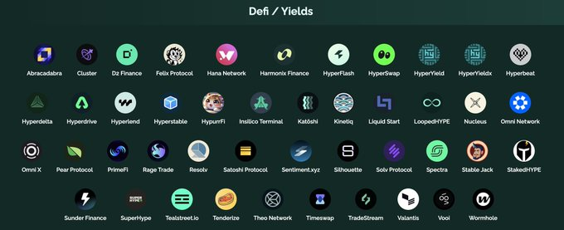

More are launching soon (
@felixprotocol
,
@kinetiq_xyz
,
@hyperlendx
). The NFT ecosystem is extremely active (
@HypioHL
,
@SaveTheWhal3s
,
@tinyhypercats
,
@HypersOnHL
,
@HyperFrogsNFT
,
@drip__trade
,
@liquidfi_app
). This has been a blast. Hypio. Still, with a TVL of just $11.3M nearly one month after launch, the money isn't flowing to HyperEVM.

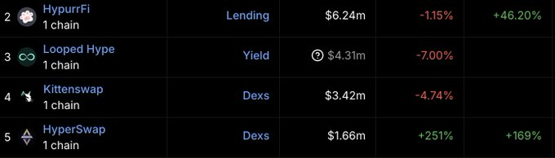

Technically, the user experience on HyperEVM is very subpar. NFT mints spiking gas and congesting the network. Confusion over enabling big block/small blocks. Nonce issues. I thought Hyperliquid would go to market with a highly performant EVM, but that hasn't been the case. Things that are table stakes for chains today are lacking on HyperEVM. Sell-the-news? Yeah, its turned out to be that way with HYPE nearing $13. Of course, that is in large part due to the overall market downturn, and today's "exploit."

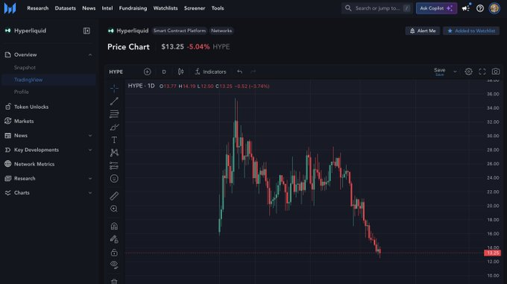

Medium/long-term, I'm not concerned. Hyperliquid is one of the highest revenue-generating machines in all of crypto. I haven't sold a single $HYPE. It's all staked and nearly half is deployed in HyperEVM DeFi. Still, things needs to change, and in this order. 1) If HyperEVM is a priority, then Hyperliquid and
@chameleon_jeff
need to fix the performance issues. Get this chain butter smooth to use like every other next-gen chain out there. 2) If HyperEVM is a priority, then Hyperliquid will need to bootstrap liquidity/activity. It's the truth at this point. Without a focus on ecosystem and community, its already been proven that users/liquidity are not flocking to HyperEVM. It needs to be spurred. Luckily, Hyperliquid has a massive chest of HYPE. 38.88% for "future emissions and community rewards." Not to mention the Assistance Fund has acquired over 5% of the initial circulating supply. There is room for upside surprise here, and that is increasingly likely going to need to be the catalyst to kickstart activity on the HyperEVM. Hyperliquid
https://x.com/Solofunk30/status/1899877956148969569

I was originally a $HYPE skeptic and fumbled my airdrop but looking at the data it is obvious we're dealing with a Top 10 asset here. Hyperliquid already commands >3% market share over total open interest in the industry, only behind CEXs. Given its quickness to list assets, superior UX and upcoming mainnet launch I'd expect Hyperliquid to rise to 4th in terms of OI venues in 2025 only behind the giants in Binance, CME, and Bybit. Looking at the revenues generated by the exchange it is trading at significantly better multiples than $ETH or $SOL and this is just with a single perp DEX product. Once mainnet launches, fees will significantly increase given a plethora of apps and an appetite from users to dive into the Hyperliquid trenches, particularly with 39% of tokens ($9bn) still to be emitted to the community via further incentives. Not to mention an incredibly powerful value accrual mechanism that directs all fees to the HLP vault+the assistance fund, with the latter having purchased $324mn of $HYPE in the open market over the last 3 months. If you don't have exposure at this point it would be wise to reevaluate before you get left behind. Hyperliquid.
https://x.com/Daveeemor/status/1882783239393136699

A couple key value props: 1) Token Immaculate conception and negative *internal* sell pressure HL took no funding, and distributed all tokens to users with a lean team allo. Incoming buy pressure includes: - Constant TWAP buys from Hyperliquid revenue, often 7 figs per day - Leverage unlock from lending platforms + using HYPE in defi. Most hype is sitting dormant or staked at 1x lev. - Support by T1 CEXes / USDC CCTP. Bridging to arbitrum -> HL is still a massive headache, and unfamiliar for custodians. Hyperliquid has bought back $200m of $hype so far on the open market, while insiders on every other L1/Exchange are dumping on our heads. 2) Grand vision to house all of finance Jeff and team have an ultimate goal to put *everything* onchain supported by HL. Something to 'believe in' which could lead to a bullish overextension at some point in the cycle. No matter how you frame it, Hyperliquid is valuable. Visual from
@RyanWatkins_
depicts upside potential whether it's 'just a perps dex', 'just an L1', or the everything exchange. Recommend reading his whole thread as he put it much more elegantly than I can:
https://x.com/GuthixHL/status/1901428578841198673

Hyperliquid Thesis: The Road to Financial Aggregation
Mar 5
Written By Ryan Watkins
In Q4 2024 Syncracy built a large position in HYPE. In Q1 2025, Syncracy added to its position as the Hyperliquid story accelerated beyond expectations and our conviction grew.
We believe Hyperliquid possesses a unique revenue engine, fusing an exchange and smart contract platform, that positions it to become the highest fee-generating blockchain in the cryptoeconomy. Furthermore, its vertically integrated design, combining these two businesses through a unified interface, enables Hyperliquid to aggregate users more effectively than any peers to date, providing structural advantages in its ambition to house all global finance.
The exchange alone has the potential to disrupt Binance long-term, offering superior performance over decentralized peers, and structural advantages over centralized exchanges in cost, accessibility, auditability, composability, safety, and asset availability. Meanwhile, its smart contract platform has the potential to become one of the leading application ecosystems, leveraging Hyperliquid’s exchange and captive base of traders as the foundation for growth.
We estimate the combined market size of its exchange and smart contract platform, which we deem the “Financial Aggregator” opportunity, to be valued in the centi-billions of dollars over the coming years.
Below we share our thesis.
View fullsize
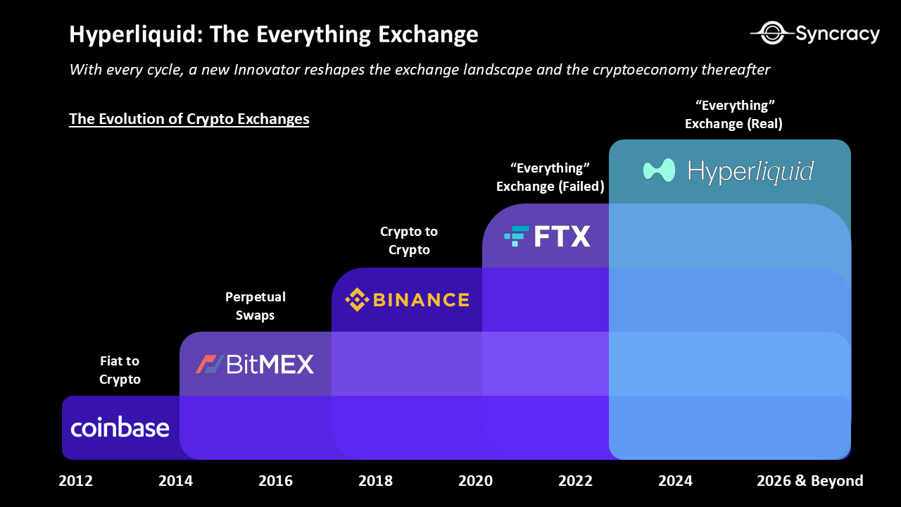
Note: Inspired by Frictionless Capital
The Art of Progressive Decentralization
Trading is one of the cryptoeconomy’s clearest killer applications to-date, yet most of it is still done in centralized venues. Is it possible instead to build a decentralized exchange with a Bitcoin-like genesis? This is the question Hyperliquid co-founder, Jeff Yan, set out to answer in 2022 when he launched a new exchange out of the ashes of FTX.
Following a successful quantitative trading career at Hudson River Trading, Jeff found himself in a comfortable position to take a big entrepreneurial leap and launch Hyperliquid with his former Harvard classmate and co-founder Iliensinc. Notably, the team did not take any outside funding from venture capitalists and instead decided to bootstrap the entire project themselves. This was a key decision that allowed the team to both focus on building a product they believe in without external pressure, and eventually distribute the majority of the ownership to the community.
Two years later, Hyperliquid has become one of the fastest-growing projects in the cryptoeconomy, commanding over 60% market share in the onchain perps market. In doing so, it has played a pivotal role in spearheading the shift to onchain perps trading, which now accounts for 12% of global trading volumes.
View fullsize
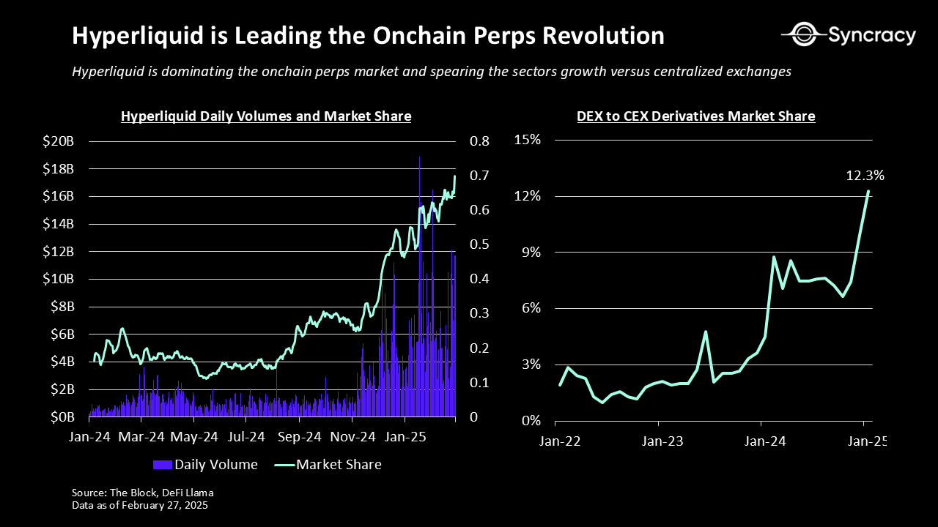
What’s been Hyperliquid’s key to success?
It all starts with the team's product-first philosophy. Rather than optimizing for ideological purity, such as prioritizing maximal decentralization from day one, the team instead optimized for delivering the best possible onchain trading experience. This strategy is best understood as progressive decentralization – a practical approach for building a winning project in the cryptoeconomy, that involves teams first finding product-market fit, then gradually relinquishing control over time.
The key insight that the team understood is that while decentralization and open-source software are crucial in the long-run in order to reduce counterparty risk and enable greater product scalability, most users preferred performance and usability over rigid adherence to cypherpunk principles. So for the two years leading up to the HYPE token launch, the team relentlessly refined the platform through direct engagement with traders.
This feedback loop proved invaluable as the Hyperliquid team frequently implemented feature requests and bug fixes within hours, building deep trust within the community. It also led to key product features such as order cancel prioritization for traders, which enables market makers to quote tighter spreads, and Hyperliquid vaults, which enables the exchange to quickly bootstrap liquidity for new pairs. The result was a high-performance chain with an enshrined orderbook (CLOB) capable of 100K transactions-per-second (tps) throughput and sub-second finality – an order of magnitude performance improvement over peers.
As volumes grew exponentially into year-end 2024, the Hyperliquid team executed its most ambitious move yet – airdropping 31% of its token supply to its users. The airdrop was an overwhelming success because Hyperliquid already had proven product-market-fit – a stark contrast to most other projects that list their tokens publicly prematurely.
View fullsize
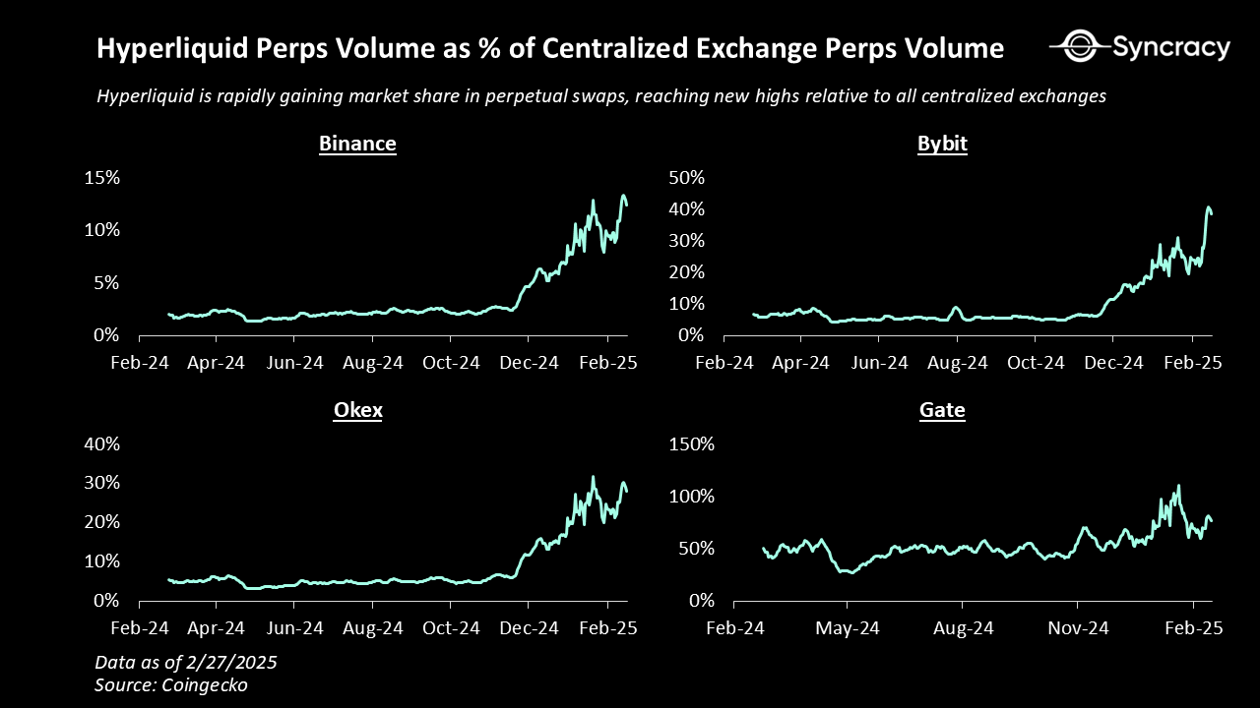
Crucially, the HYPE token also had clear intrinsic value, with fees run-rating at $228M per year at the time. This not only provided strong incentives for recipients to hold rather than immediately sell, but also created strong buying pressure for HYPE as the fees fueled large scale buybacks. Additionally, with no pre-allocations to any insiders beyond the core team, the airdrop created a scenario where any large buyers who wanted exposure were required to buy in public markets. This was a strategic masterstroke as it not only forced these players to onboard directly onto Hyperliquid, increasing volumes in lockstep, but also highlighted Hyperliquid’s next evolution as more than a simple derivatives exchange, first starting with spot markets.
View fullsize

The Everything Exchange
Exchanges are winner-take-most markets, where liquidity network effects, scale efficiencies, brand equity, and regulatory moats concentrate trading activity among a few dominant players. This pattern has shaped financial markets for centuries, cementing the dominance of leaders such as CME in derivatives, NYSE and Nasdaq in equities, and Binance in centralized crypto markets. Yet, despite their scale, no exchange has ever fully unified liquidity across multiple asset classes on a single global ledger – a concept we call the “Everything” Exchange.
Bridging this gap requires more than just dominance in a single market – it demands infrastructure that can seamlessly integrate multiple asset classes, unify liquidity, and scale globally. This is where Hyperliquid’s design diverges from traditional exchanges, offering a vertically integrated system that consolidates liquidity across both spot and derivatives markets while operating on its own high-performance blockchain.
Blockchain based exchanges provide structural advantages in auditability, efficiency, safety, composability, and accessibility. Instead of entrusting assets to centralized entities with opaque risk, users can self-custody assets and trade in global, 24/7, near-instantly settled markets using autonomous smart contracts as intermediaries.
These benefits aren’t just theoretical. They’re already driving volumes onchain today. This trend is not only observable in the data, but also in the strategy of two of the largest exchanges in the industry, Binance and Coinbase, which launched their own respective blockchains – Binance Smart Chain (BSC) and Base – to position ahead of this transition.
Hyperliquid understands this opportunity and is already taking its first step towards it through expanding into crypto spot markets. The solution starts with enabling users to send native assets from blockchains such as Bitcoin, Ethereum, and Solana to Hyperliquid through an enshrined interface. This is a first for an onchain exchange as historically all have either been single-chain or spot only. Hyperliquid will be the only onchain CLOB to feature both multi-chain spot and derivatives markets, replicating the centralized exchange experience onchain for the first time in history.
With HYPE and BTC as the only large cap asset that Hyperliquid currently supports in its spot markets, it is already a top 10 DEX and top 5 chain by DEX volumes in the world. We anticipate it will rapidly climb up the ranks as it imports the largest assets in the cryptoeconomy to trade, adding 9 figures of earnings within the first year post launch, assuming spot volumes reach 30% of Perps volumes, as is the typical ratio for exchanges that service both markets.
View fullsize
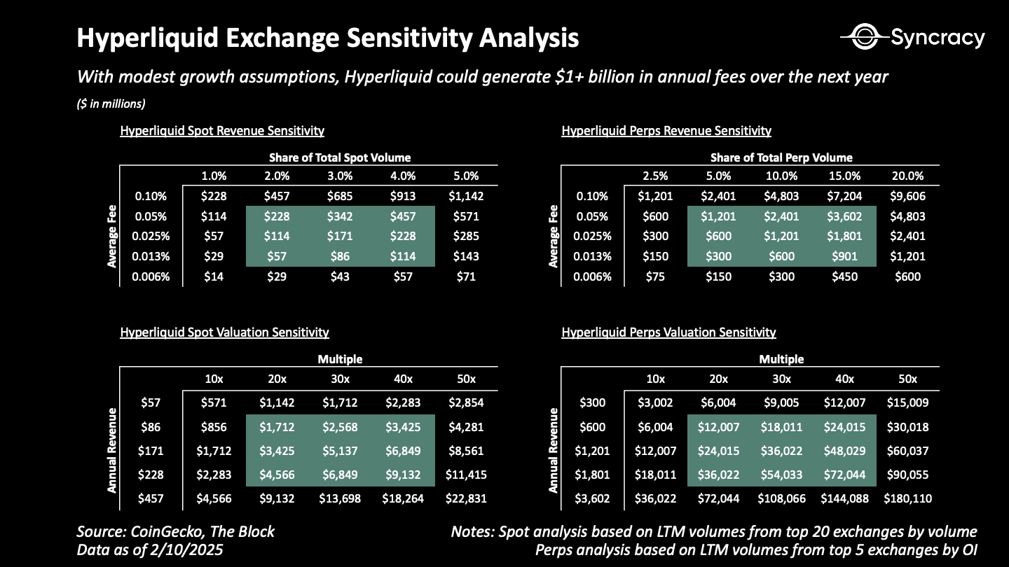
Hyperliquid should continue to outcompete its centralized peers due to its advantages in:
- Cost – significantly lower trading fees and overhead than CEXs like Binance
- Accessibility – easier for users to onboard due to its global permissionless nature
- Auditability – easy to verify using basic public-key cryptography inherent in blockchains
- Composability – easy for third parties to develop atop of (e.g builder codes)
- Safety – self-custodial with chain decentralization improving over time
- Asset availability – quicker, more transparent process for asset listings
Moreover, these advantages enable Hyperliquid to eventually expand beyond blockchain-native assets. As tokenization efforts accelerate Hyperliquid’s opportunity may encompass all assets globally including currencies, stocks, bonds, commodities, real estate, and even exotic markets such as sports betting and prediction markets. In fact, we believe this shift is practically inevitable. As wallet adoption grows, asset issuers will have an increasingly strong incentive to list on public blockchains to tap into a global investor base for increased distribution and for access to the lowest cost of capital.
Zooming out, we estimate the opportunity within the cryptoeconomy today is worth over $140B+. We furthermore estimate the opportunity beyond the cryptoeconomy, which encompasses every asset class and exchange on the planet, to be worth a minimum of $500B+ globally, which doesn’t include private exchanges, exotic assets, or large OTC markets like foreign exchange. Inclusive of those, the market opportunity would easily enter the trillions of dollars. Again, we believe that blockchain based exchanges are a massive expansion of the exchange opportunity.
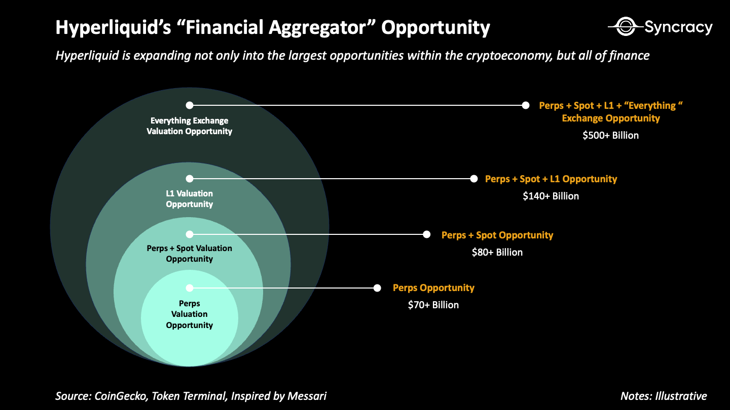
Note: you can find our valuation assumptions in our model here
In its short history, Hyperliquid has already achieved a $577M annual run-rate in revenue solely from its perps exchange and adolescent spot markets. Should any of the above thesis play out over the coming 12 - 24 months, we expect revenue to expand multiples going forward, likely catapulting Hyperliquid to the top of the cryptoeconomy in terms of onchain revenue (it is already #3).
View fullsize
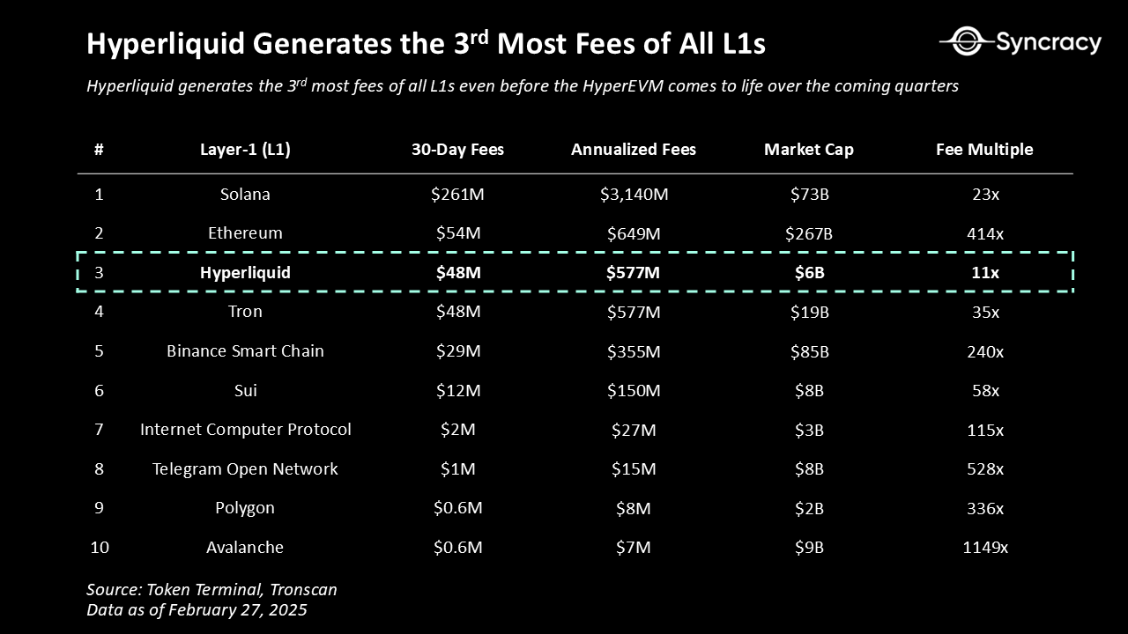
The Road to Financial Aggregation
The “everything exchange” opportunity alone provides more than enough potential to get excited about with its multi-trillion dollar TAM. Could there possibly be even more to the story?
In the prior section we mentioned how Binance and Coinbase launched BSC and Base, respectively. The two chains are separate entities from the exchanges, with separate cap tables and PnLs. But what if, for example, Binance and BSC were combined? What if in essence you combined two of the most profitable businesses in the history of the cryptoeconomy: exchanges and smart contract platforms? What if you furthermore made them both accessible through a single interface? This is the opportunity Hyperliquid has with its recently launched HyperEVM, an EVM compatible virtual machine that will run in parallel with its order book exchange.
View fullsize

We believe that with its exchange as the initial killer app that directly owns user order flow, Hyperliquid is well positioned to become one of the cryptoeconomy’s first aggregators. In essence, by tightly integrating its interface, exchange, and smart contract platform into one cohesive experience, Hyperliquid can aggregate users at scale, creating unmatched leverage over developers and asset issuers compared to peers.
This is a big deal as historically the three have been fragmented in the cryptoeconomy. For example, Base is Ethereum’s most successful rollup, but is mostly separate from the broader Coinbase product suite and primarily accessed through third party interfaces. Uniswap verticalized the wallet, interface, order router, exchange, and rollup, but inherited Ethereum’s technical debt from its messy modular roadmap. Solana is the most used blockchain in the cryptoeconomy, yet outsources the user experience to external builders like Pump and Jupiter, the latter of which is partially leaving to launch its own chain.
In contrast, Hyperliquid integrates the entire stack, only partially modularizing its application and interface layers – a design choice that creates a potential strategic advantage. Unlike ecosystems that rely entirely on third-party applications and interfaces, Hyperliquid’s in-house exchange serves as both an anchor and a distribution hub, reinforcing its network effects. The exchange serves as a top-of-funnel for third-party developers to build applications and issue assets that can integrate directly with the flagship Hyperliquid interface, where users are concentrated. This creates a powerful feedback loop. The more users on the exchange, the more liquidity is available to applications. The more liquidity available to applications, the more useful the applications become. The more useful the applications become, the stickier the Hyperliquid ecosystem, and the more valuable Hyperliquid becomes over time.
Pulling this all together, the shared state between the Hyperliquid exchange and the HyperEVM could lead to a number of synergies and product innovations such as:
- Advanced Collateral Management – a prime brokerage app that makes it simple for traders to achieve maximum capital efficiency on their collateral – e.g. lending out liquid staked HYPE via an Aave-like protocol, selling the interest through a yield market like Pendle, while simultaneously using that position as collateral for a derivatives trade
- Onchain Structured Products – an asset management app that leverages Hyperliquid vaults and derivatives to create onchain structured products similar to Ethena
- Social Trading – a social trading app can expand its group trading strategies through Hyperliquid vaults or allow traders to automatically capture a portion of copy trading fees through builder codes
- Advanced Money Markets – a money market protocol that integrates Hyperliquid’s derivatives exchange to hedge collateral risk and spot exchange for liquidations, ultimately enabling it to offer higher loan-to-value (LTV) ratios for borrowers
- Private Trading – a privacy protocol akin to Tornado Cash that enables anonymous order placement (Dark Pools) on Hyperliquid’s exchange
These examples barely scratch the surface – the deep integration between Hyperliquid’s trading interface, order book, and smart contract ecosystem is fertile ground for an entirely new wave of onchain financial primitives.
Hyperliquid has a couple of important levers to pull to bootstrap its ecosystem – a key competitive advantage in what is an increasingly saturated smart contract platform landscape. These levers revolve around its captive community of user-owners and its warchest of incentives.
- Captive Trading Audience – Unlike most emerging smart contract platforms, Hyperliquid already has a massive, highly engaged user base. This solves the cold-start problem that plagues ecosystems outside of Ethereum, Solana, and Base, giving developers an instant market for their products
- Incentive Warchest – at genesis, Hyperliquid allocated 39% of its supply (~$9 billion today) for community rewards and incentives, allowing it to launch a multi-year, multi-billion-dollar campaign to attract users and builders
- Assistance Fund Buybacks – Hyperliquid announced it would begin buying ecosystem tokens with its assistance fund to spark onchain activity and support its community
Builders in the HyperEVM ecosystem are acutely aware of these advantages and are structuring their go-to-market strategies accordingly. Many are inspired by Jeff and extremely aligned with HYPE holders, which will likely lead to many airdropping their token supplies to Hyperliquid users and HYPE stakers. This dynamic can be understood similarly to Binance’s launchpad – one of the biggest demand drivers for BNB (next to its exchange revenues), which even today commands a $90 billion valuation despite BSC being practically dead.
Additionally, there’s a handful of projects promising to allocate a portion of their treasury to HYPE, which may create additional demand for HYPE as they ramp up revenue. This may be important in developing the story of HYPE as a non-sovereign store of value similar to ETH and SOL which are also the reserve assets of their ecosystems. As HYPE adoption scales across the HyperEVM, its role as gas, collateral, and a quote pair will further this narrative, potentially enabling HYPE to command valuations far beyond what MEV and execution fees alone would justify. This would cement its status as a core asset in the cryptoeconomy alongside BTC, ETH, and SOL.
View fullsize
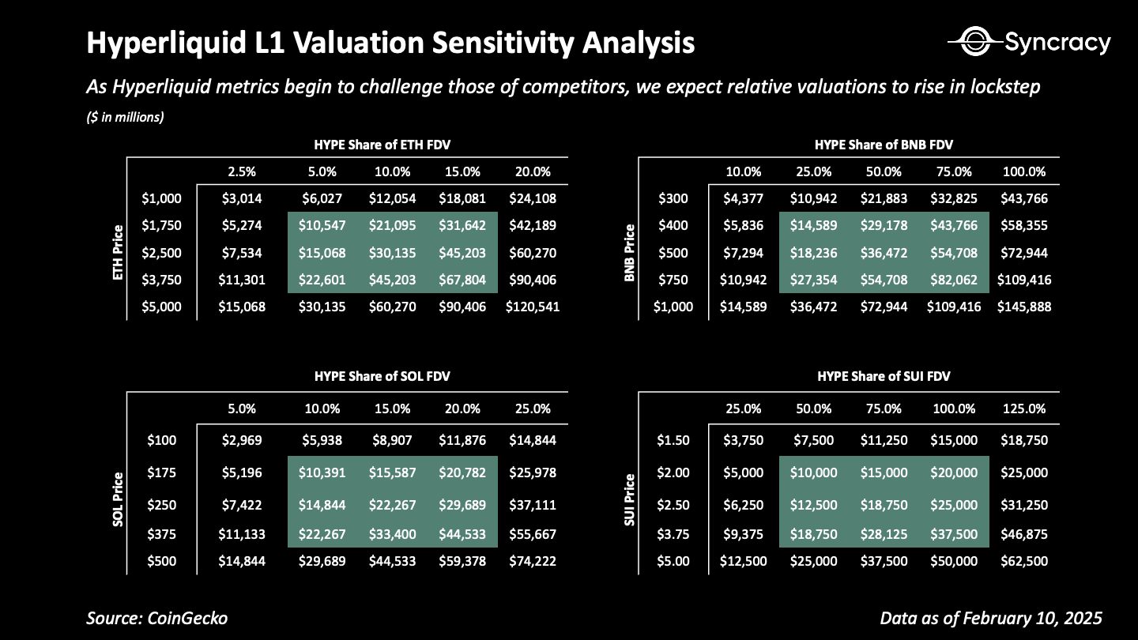
Hyperfinancialization
As time passes, breaking into the exchange or smart contract platform markets is becoming an increasingly formidable challenge. Both are network-effect-driven businesses, dominated by entrenched global leaders, and likely to consolidate into power-law market structures over time. Competing in these arenas without a distinct and compelling value proposition is not just difficult – it’s foolish.
We believe Hyperliquid is one of those rare new entrants that can meaningfully dent both markets. Its vertically integrated design, coupled with a product-first mentality, has made it one of the fastest-growing projects in the history of the cryptoeconomy. More importantly, Hyperliquid has a unique revenue engine and is positioned to become the highest fee-generating blockchain in the world by capturing both exchange and smart contract platform fees – an advantage no other smart contract platform or exchange can claim.
Of course, the thesis is not without risk. Beyond the execution risks inherent in any early stage venture, there are risks related to:
- Centralization – Hyperliquid may not be able to globally distribute its validator set, which currently consists of 16 co-located servers in Tokyo, without performance degradation; moreover its inability to decentralize may open regulatory risk
- Developer Ecosystem Buildout – Hyperliquid has primarily been developed by the core team with minimal outside contribution; with much of the code still closed source and the HyperEVM in its infancy it could be an extended buildout towards a robust ecosystem of third party contributors
- Protocol Enshrinement – It's an open question whether it makes sense to enshrine all of the infrastructure necessary to run an order book exchange onchain, especially as it relates to the perpetual swaps product which requires a protocol-owned insurance fund to protect against insolvencies – an exposure Ethereum and Solana do not carry, as they outsource solvency risk to third-party exchanges built on their platforms
- Bridge Hacks – Hyperliquid’s spot markets may be undermined if it cannot convincingly decentralize its bridging infrastructure; moreover lack of native stablecoin support creates unnecessary counterparty risk
- Business Cyclicality – Exchanges are cyclical businesses and declining interest in the asset class will lead to lower volumes and lower fees
Despite these risks, Hyperliquid’s track record speaks for itself. Time and again, the team has demonstrated world-class execution, with no signs of slowing down. Perhaps that is the most important factor of all, given how early Hyperliquid is in its life cycle.
It is rare to find founders operating at this level. Even rarer to find them building simultaneously in two of crypto’s largest markets. Our experience has taught us that when you encounter opportunities of this magnitude, it pays to bet, and bet in size.
The cryptoeconomy is evolving from the old guard of ideologically-motivated dreamers to commercially-oriented builders who will deliver blockchains to the masses.
The lines between financial markets are dissolving, converging into a single, composable, hyperliquid financial system. In time, the old financial world’s collection of siloed ledgers, intermediaries, and clearinghouses will give way to one unified, real-time, programmable economy.
We’re excited to back Hyperliquid as it makes a run towards this vision.
The road to Hyperfinancialization is in full swing.
Hyperliquid.
https://www.syncracy.io/writing/hyperliquid-thesis
https://x.com/RyanWatkins_/status/1897302198201036902

Hyperliquid exchange volume / CEX exchange volume (%) is up and to the right. Granted, some exchanges are not trading perpetual futures or are doing so in small size (coinbase intl), but we can see the following: Hyperliquid is processing: > 8% of Binance daily volume > 20% of Bybit daily volume > 50% of Gate daily volume > 175% of Coinbase daily volume > 23% of OKEX daily volume > 600% of Kraken daily volume
https://x.com/Ren_gmi/status/1890108573084250261

https://x.com/0xlykt/status/1900951564216672374
The Hyperliquid Thesis This is going to be a very long thread explaining why I am so bullish long-term on Hyperliquid, the Hyperliquid ecosystem and $HYPE, including some points which people might easily overlook.
1. The Perp DEX Hyperliquid has proven to be the only perp dex that can compete with CEX volumes and OI, and it completely dominates all other perp dexes in market share. We can attribute this dominance to a few main reasons: - Best in class liquidity and execution. Other perp dexes struggle with illiquid orderbooks, limited asset selection, lack of advanced order types and occasional latency issues. Hyperliquid experienced these issues in its early stages, but managed to fix them quickly and has dominated ever since. - Low fees relative to CEXes. Hyperliquid has the lowest fees (0.035% maker and 0.01% taker, decreases with more volume) for futures trading compared to all the major CEXes. - Organic growth instead of mercenary capital. Hyperliquid usage actually rose after $HYPE TGE, in contrast with other perp dexes with metrics that fall off a cliff after they TGE.
2. The Assistance Fund Almost all trading fees from Hyperliquid go to the Assistance Fund (the rest go to HLP), which is used to buy $HYPE on the open market. The AF currently holds 5.2% of the circulating supply. This allows revenue from the exchange to accrue directly to $HYPE holders. Almost all crypto projects have zero value accrual to the token (no one is buying tokens for governance purposes), but the Assistance Fund provides a floor for $HYPE by being a price-insensitive buyer. We can construct valuation models for $HYPE based on this revenue which actually look undervalued by tradfi big tech standards - refer to this excellent post by @keisancrypto:
3. No VCs Hyperliquid Labs is entirely self-funded. The $HYPE TGE had zero allocations to market makers, private investors or CEXes. Core contributor tokens are locked until late November, and most vesting completes between 2027 and 2028. VCs have to sell eventually as they have mandates to follow - in contrast, core contributors don't need to sell, especially if they're already rich and didn't need any external funding to build Hyperliquid.
4. HyperCore + HyperEVM synergy This is a very big one - no other blockchain is as well-equipped to be the onchain house of finance as Hyperliquid is with its unique design. HyperCore consists of performant native components: perp and spot orderbooks, staking, oracles, multi-sig, etc. HyperEVM is a general purpose world-computer, allowing builders to deploy code that interacts with both HyperEVM and HyperCore. Together they form ONE composable state secured by HyperBFT consensus (i.e. no need for bridging, proofs, or trusted signers, in contrast to the Ethereum ecosystem) Here's 2 examples of why this design is superior to every other option we currently have: Example 1: Project ABC deploys a $ABC token contract on HyperEVM and a corresponding spot asset $ABC in the spot ticker auction on HyperCore. The HyperCore and HyperEVM token contracts can be easily linked, allowing users to transfer their $ABC balance to HyperCore for order book trading. Compared to CEXes: 1) The entire process is permissionless, with no need to pay CEX listing fees. 2) There is no bridging risk between HyperCore and HyperEVM (they are ONE unified state!). In contrast, CEXs need to deposit and withdraw through wallets that could be hacked (like Bybit was for over $1B recently) Example 2: A lending protocol accepts $HYPE as collateral and lends $USDC to the borrower. To determine the liquidation threshold, the lending smart contract can easily read $HYPE prices directly from the HyperCore order books using a "read precompile." If the borrower's $HYPE position requires liquidation, the lending smart contract can liquidate the $HYPE collateral for $USDC on the HyperCore order books using a "write precompile." In contrast to AMM-based liquidations on all other chains (be it Ethereum, Solana etc), orderbook based liquidations offer far more efficient liquidations. Refer to this excellent post by
@0xBroze
to learn more about how these liquidations are a significant upgrade: https://x.com/0xBroze/status/1900525372707574012
5. Builder codes Builder codes are probably one of the most overlooked aspects of Hyperliquid. Some of you might have heard of
@pvp_dot_trade
- did you know they use builder codes? Builder codes allow projects to use Hyperliquid's infrastructure and liquidity for zero cost. To make a web2 comparison, builder codes are like AWS but for liquidity. Here's a great breakdown by
@0xOmnia
on the potential of builder
6. Spot token listings Hyperliquid is the only perp dex which supports spot trading on majors (on BTC for now, with ETH and SOL coming soon). This is convenient for traders who wish to trade BTC without paying funding, or want a convenient way to farm basis (long spot BTC, short perp BTC) within one platform. The only thing Hyperliquid is missing now compared to CEXes is the ability to use spot assets such as BTC or HYPE as margin instead of only USDC. However, since major CEXes offer this functionality, we can be quite confident that Hyperliquid will eventually include this feature.
7. Dedicated community and builders Hyperliquid has developed one of the most dedicated (arguably fanatical) communities in crypto history. Of course, a significant amount of this enthusiasm can be attributed to $HYPE TGE being the largest airdrop in crypto history. However, many Hyperliquid believers have seen how this team is one of the few teams in crypto who actually focus on building a good product, not just extracting capital, and this is why many are so passionate about it. There is also a vibrant builder community in Hyperliquid, and most projects are built natively on HyperCore or HyperEVM instead of being bridged over from other chains. Only a few are live on HyperEVM for now, since many features of the HyperEVM have not been released yet. However, once HyperEVM exits its "alpha" phase, we will see plenty of projects migrating from testnet to mainnet. Hyperliquid is the next Solana, but better.
Tagging some HL chads:
@GuthixHL
@Sakrexer
@crypto_adair
@Henrik_on_HL
@degennQuant
@0xRyomenSukuna
@derteil00
@NMTD8
@0xPasteke
@Shuri2060
@stevenyuntcap
@kirbyongeo
@fiege_max
@MetamateDaz
@GreenGeorgeHL
@SamuraiTakedown

Unlocking Efficient Liquidations: The Power of HyperCore<>HyperEVM Composability
7
85
239

22K

DeFi has long relied on AMMs as the backbone for liquidity provisioning in money markets. While AMMs have successfully enabled permissionless trading and liquidation processes, they inherently suffer from inefficiencies such as untenable slippage, high price impact, and impermanent loss due to the mechanisms through which they price assets. Hyperliquid presents a fundamental shift in this paradigm by integrating a robust on-chain orderbook to process liquidations necessary on the HyperEVM. When this composability is in practice, this can hopefully change how we think about pricing efficiency, capital efficiency, and the overall user experience for both lenders and borrowers in DeFi money markets.
This brief article will break down a bit of the innovation via the interaction we can expect between HyperCore and HyperEVM and its direct benefits on returns for borrowers and lenders in HyperEVM money markets.
Why Orderbook-Based Liquidations Are a Step Function Upgrade
1. Superior Pricing and Capital Efficiency for Liquidators
In traditional DeFi protocols like Aave and Compound, liquidations tend to occur through AMMs, where assets are sold into liquidity pools at predefined price curves. While effective at maintaining solvency, these mechanisms often lead to excessive slippage and suboptimal price execution for liquidators.
In contrast, Hyperliquid’s orderbook-based approach allows market makers to directly place buy and sell orders, leading to tighter bid-ask spreads, deeper liquidity, and more predictable pricing. (This is just the high level benefits of an on-chain orderbook over an AMM with liquidity pools.) If it is not obvious upon initial use, historical data from centralized orderbook models, including both Binance and Nasdaq, consistently makes clear that orderbooks facilitate more precise price discovery and reduced transaction costs compared to AMMs. Additionally, orderbook-based liquidations enable more flexible liquidation sizes over time rather than relying on excess slippage from an AMM, allowing more granular and optimized execution. This further reduces price impact and preserves borrower collateral value.
On a 50k HYPE liquidation, a liquidator will hopefully be able to atomically process (only partially atomic now via precomplies) this tx and sell this HYPE (if not willing to take the inventory risk) for about 1% slippage currently on the orderbook. This would not be possible (at least for some time) on the AMM side, and when it is, the orderbook liquidity will continue to be deeper. For liquidating majors, the orderbook will almost always be the more capital efficient option and all liquidators to save on slippage costs.
2. More Yield for Suppliers, Lower Costs for Borrowers
A direct result of improved capital efficiency for liquidators is the redistribution of costs and incentives in the money market ecosystem. When liquidators experience lower slippage and better trade execution, the cost of liquidation incentives decreases as highlighted above. In regular DeFi borrow/lend, high liquidation incentives (typically 5-10% of collateral value) are necessary to attract liquidators. This is often due to the slippage liquidators will face when processing liquidation transactions via an AMM. However, HyperCore<>HyperEVM composability can reduce these costs, enabling higher yields for suppliers and more affordable borrowing rates for borrowers/stablecoin minters. This can also enable higher max LTVs, as LTVs are in part a function of required liquidation incentives (liquidation incentives + max LTV can never be > 100). By opening liquidation incentives due to more efficient liquidations on the orderbook, we can get closer and closer to 1:1 DeFi loans.
For an example on how this mechanism upgrade leads to user growth, historical liquidation penalty data from Aave v3 suggests that even small reductions in liquidation penalties (e.g., from 8% to 5%) can lead to increased borrower participation and protocol growth. If Hyperliquid can significantly lower liquidation costs while maintaining system solvency, this could unlock substantial market expansion from users looking for the best rates possible, both on the supply side and the borrow side.
And lastly, ideally utilizing HyperCore for liquidations can help HyperEVM borrow/lend protocol teams to more effectively and safely implement partial liquidations (E.g. 10% of collateral position eligible for liquidation if health score < 1 instead of 100% of collateral). This prevents borrowers from losing excessive amounts of collateral due to aggressive liquidation mechanics found in AMM-based systems. Partial liquidations can significantly reduce borrower losses and system-wide deleveraging risks--just better risk management at the liquidation level.
How Do These HyperEVM<>HyperCore Liquidations Function In Practice?
Assuming that liquidators do not want to take the inventory risk of repaying borrowing, and then earning the liquidation incentive which they can then manually transfer to HyperCore in order to hold or sell, HyperCore<>HyperEVM liquidations in practice will function via precompiles. For those unfamiliar, precompile contracts essentially allow smart contracts deployed on the HyperEVM side to emit events to the L1. These events can include the necessary transactions in order to fully process the liquidation from a user on, say,
@felixprotocol
on HyperEVM via the Hyperliquid spot orderbook. More capital efficiency unlocked for both Felix borrowers and suppliers.

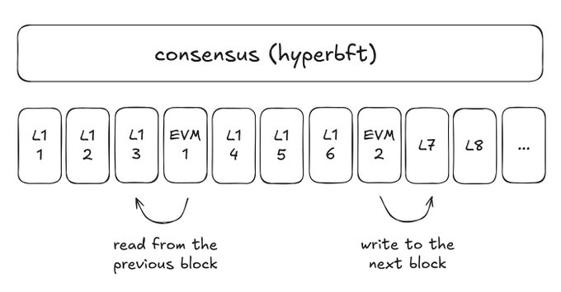

Source: Ambit
The Future of Borrow/Lend Liquidations
This HyperCore<>HyperEVM dynamic relationship has the potential to redefine how decentralized money markets operate from a liquidation penalty perspective, ideally increasing capital efficiency and user security across Hyperliquid. Build the best apps on the best fountain of liquidity-- should be fun to see what happens next.
https://x.com/0xBroze/status/1900525372707574012

